

**PES UNIVERSITY**

**Department of Computer Science**

**MPCA Project Report**

**Submitted by**

**01FB14ECS237 Shuaib Ur Rahman**

**01FB14ECS207 Sandeep Pvn**

**01FB14ECS200 Sagi Kishan Varma**

**01FB14ECS219 Shashidhar BG**

**For the academic year 2015-2016**

**Under the Guidance of**

**Prof. Ashwini**

**Assistant Professor**

**Department of Computer Science and Engineering**

**PES UNIVERSITY**

**Table of Contents**

Project Abstract: ..............................................................................................................................

Project Features/Objectives: ..............................................................................................................................

Concept/Technology selection

..............................................................................................................................

Project picture

..............................................................................................................................

Code

..............................................................................................................................

**Project Abstract:**

Our project consists of building a 3 dimensional LED array that will be able to display various graphics through the concept of persistence of vision. The array will be in three directions, allowing it to focus certain graphics to a targeted audience. There will be several options for displaying patterns including :-

* Spiral in out
* Strom up down
* Flicker on off
* Random rain
* Random flicker
* Edge down
* Diagonal rectangle
* Propeller

**Project Features/Objectives:**

The goal of this design is to be able to output and modify the LED array fast enough to see a pattern The first issue that must be dealt with is the physical construction of the array. The array will be 4x4 LEDs, accounting for a total of 64 devices. Due to lack of accessibility we will have to make certain that each LED is functional and stays so throughout the construction.

• A sturdy base and casing will also have to be provided for the array, as the construction

doesn’t allow for a large amount of structural integrity. A cardboard base and a

case is proposed to deal with this issue and to protect the LED array from general jostling

and movement.

• Due to the very large number of LEDs that need to be used at once, current considerations will have to be taken into account, verifying that we have enough power to supply a good level of luminescence so that we may not only turn on all LEDs

**Concept/Technology Selection:**

We have chosen the implementation of this project based on our teams experience and the simplest methods by which we see to complete our goals.

When constructing the actual LED array we have chosen to construct the array in layers, verifying that all LEDs function after every step. Due to close proximity soldering there is a high chance that some of them may burn out and we would like to catch this early on. Once we have all layers completed we will stack them and solder the layers on by one till they are fully assembled. We shall also place several strong strands of wire to support the structure and increase its integrity.We have chosen to do the main processing in C through out.

Since all team members have significant experience in coding this device and language it will help develop more intelligent and succinct code. The digital hardware that will be the basis for the LED driver will come from an FPGA. This will allow us the benefit of speed to update outputs as fast as needed as well as reducing our design footprint.

**Circuit Diagram**

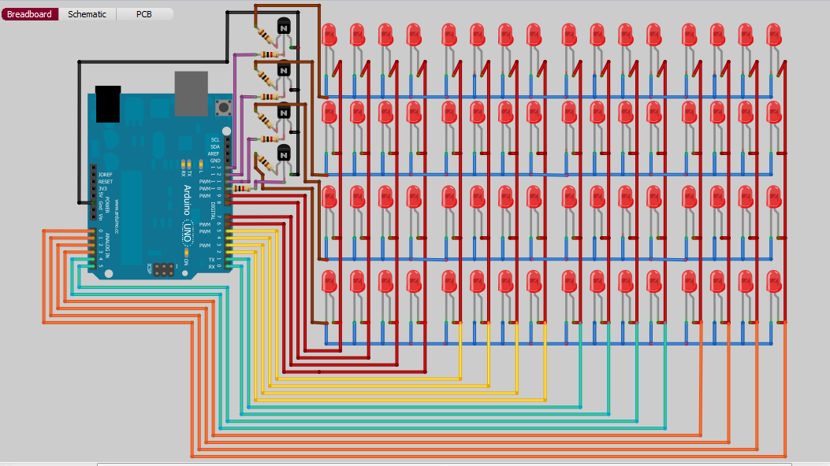

**Project Pictures**

